STC Team Meeting (1/28)

# Timestamp:

-Tuesday, Jan 28 from 11:30 - 12:30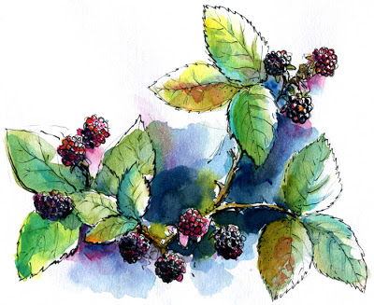

# Location:

-Library

# Members Present:

-Jayleen, Piper, Bekah

# Tasks:

-Project 2

# Discussion Topics and Conclusion:

-Pick individual editing/re-design projects

-Project 2

-Look at UI work

**-Color palette**

-Logos

# Proposed Topics for Next Meeting:

IN CLASS: What is the “preliminary Instructional and other Content Design Plan for the app”?

User Persona Profile Descriptions:

(Name, age, usage for app, etc.)

Piper- forager

Jayleen- Tourist and Scientists

Rebekah- Local residents

**WHAT IF? Berries ripen faster so harvest seasons may be different**